**try-catch Statements**

**package** Pack3;

**public** **class** MyClass1 {

**public** **static** **void** main(String args[])

{

**int**[] array = **new** **int**[3];

**try**

{

array[7] = 3;

}

**catch** (ArrayIndexOutOfBoundsException e)

{

System.***out***.println("Array index is out of bounds!");

}

**finally**

{

System.***out***.println("The array is of size " + array.length);

}

}

}

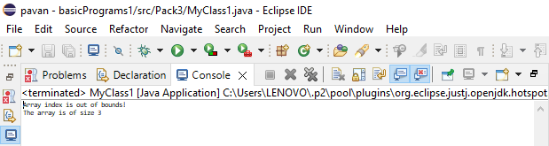

// Output: Array index is out of bounds!

The array is of size 3